New Maretron NMEA 2000 (N2K) Viewing Software from

Marine Electronic Services

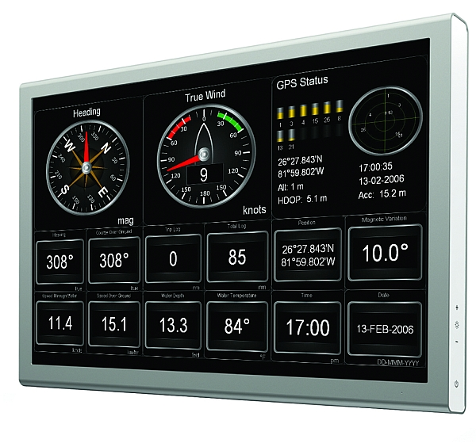
Marine Electronic Services Ltd have introduced new Maretron NMEA 2000 (N2K) Viewing Software for PCs. NMEA interface standards have evolved from the traditional NMEA 0183 to the new NMEA 2000 system and more and more products, sensors and boat builders are implementing equipment equipped with this interfacing standard.

N2K Viewing Software allows users to connect a PC to an onboard NMEA 2000 network via a simple USB interface. Users can customise the display screens to show data in digital or analogue format and the new system can also incorporate CCTV or video information via an Ethernet connection. Essentially any data available on the NMEA 2000 network could be displayed from tank levels to battery voltage, engine RPM to wind speed and direction. The list of parameters is enormous and it’s this flexibility of the N2K Viewing Software that makes it so attractive.

Two versions of the software are available - one is a simple viewing package and the other more advanced product allows control via the software. This allows users to set up switch functions on their PC to activate switches or controllers via the NMEA 2000 network. In practice, a single screen (or even Touch screen) could display and control a complete vessel’s systems similar to the fly by wire technology used in aviation.

Basic N2K Viewing Software is priced at £499.00 including VAT and is available from Marine Electronic Services Ltd
- ENDS –
For further information, please contact:
Marine Electronic Services Ltd, Marine House, Unit 10, City Business Park, Easton Road, Bristol BS5 0SP,
United Kingdom
Telephone: 01179 114111. Fax: 0870 122 1098.
Email: sales@mesltd.co.uk www.mesltd.co.uk

For further press information, please contact:
Tina Mansell at The Mansell Agency.
Telephone: 01202 701705. Mobile: 07973 850012.
Email: tina@themansellagency.com www.themansellagency.com

